EY UPDATE: 15th September 2020
Key Update: since 15th September – and until the 30th September (for now), the whole of Portugal (not just Lisbon) has moved into a State of Contingency, which isn’t a State of Emergency, but has been put in place due to schools and work returning. From a tourist point of view this does not change much, except in relation to alcohol and evenings. Specifically, after 8pm alcohol can only be served in restaurants/places which serve food, and alcohol must be purchased with a meal. These establishments can remain accepting guests until mid-night, and must close by 01:00. The sale of alcohol is also restricted in supermarkets after 8pm.
BUT… Now, these laws can be adapted by municipality, depending on the local situation. So, local councils can allow establishments to remain open until 23:00 should they wish, for example, in the Faro District of the Algarve, this is their local rules, so drinking until 23:00 is allowed in bars without meals – so check local restrictions. In addition, the general, non-location specific law is a little confusing, as while it deems alcohol can only be consumed after 8pm in a restaurant, there is another clause that says it can’t be consumed on public roads after 8pm, so in my local area for example, the police are instead enforcing it as after 8pm you can still drink, but just inside, which I think is a misunderstanding but that shows how short-term many of these laws are, and how they aren’t always understood.
The cases are, sadly, rising quite significantly in Portugal (mainly Lisbon & The North) and while I think the country has done a really good job overall, it seems, like most of Europe we are heading towards a second wave. Importantly, while cases are rising, deaths remain relatively low, and it was very much expected that cases would rise with the return to schools, work, and normal life, hence this period of contingency during these two weeks. Our PM & President have been very vocal about no further nationwide lockdown, and protecting tourism in the Azores, Madeira and the Algarve in particular where cases have remained low – but, let’s see what the next few weeks bring. I still really suggest from a tourist point of view booking everything as last minute as you can, not just for Portugal, but any travels in 2020.

Main Article: Updated September 2020
Latest updates in article: UK Airbridges for Maderia & Azores, Trip Reports, New State of Contingency and rules from 15th September, Entrance Rules, COVID-19 Stats
Over the summer, in fact since May 18th, we’ve been able to get out and explore our beautiful country of Portugal. Personally, I’ve taken road trips in the Alentejo and Central Portugal regions, beach hopping at home in the Algarve, spent a month in Lisbon for a language course and two weeks in The Azores, so have a fairly good idea about how each part of the country feels like as a tourist. Throughout, I’ve felt safe, secure and that our nation has taken precautions and health and safety seriously. Now, most Portugal coronavirus restrictions have been lifted for some countries.
For sure, many of us in the world are in the same boat when it comes to lockdowns, to varying degrees and different stages, and have likely seen a lot of our plans for 2020 cancelled. If however, you are planning to travel to Portugal in 2020, I wanted to give some insight into life on the ground, the current rules, and what has been put in place to best control coronavirus in Portugal, particularly when travelling.
*Please note, this is a fast-moving situation and the information provided below is done so in good faith at the time of writing. There are various sources linked out to throughout the article, and particularly at the bottom, however, DanFlyingSolo takes no responsibility for the information provided here and urges you to check all official sources for updates.
For the most part, I have been impressed as a Portuguese resident at the coronavirus situation in Portugal, how it was managed initially, but also with the COVID-19 travel set up in Portugal. I’ve been on many trips in the last month, and (as far as I’m aware) have not had the virus, indeed both my tests have been negative, but I’m being wary and taking all the personal precautions I can, and will try to detail the real situation below.
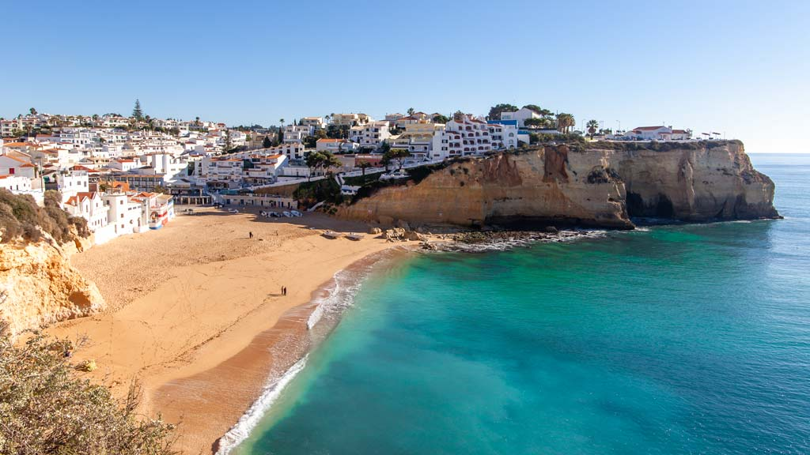
Some of the most popular beaches, like Carvoeiro, were quieter than normal and have monitoring
While I was very supportive of the lockdown initially, I very much saw it as an opportunity to get the health system prepared, and Portugals coronavirus rules and precautions in place before reopening. I didn’t see it as a permanent solution, but preparation time. Tourism is a huge part of life here in Portugal, especially in some regional, seasonal destinations like the Algarve.
It’s easy to dismiss concerns of ‘the economy’ as huge businesses, stock-markets and corporate bailouts, but there are so many small, family-run businesses here reliant on tourism, and no income this summer, means no money to pay the bills in winter – this will of course lead to huge social issues and even in a relatively left-leaning, semi-socialist country, that will become a problem,
As such, I support travel reopening, with the right restrictions in place, and if you are comfortable travelling right now, and can be respectful and take those precautions great – I fully understand it isn’t for everyone just now, but I don’t think we should be shaming everyone who is deciding to travel in the most responsible way they can either.
Here is the current situation for Portugal travel restrictions, and how my recent trips in Portugal have gone down. You can also find a list of resources at the bottom of this page (in various languages) to keep updated, and I’ll aim to update this post weekly.

Dan flying solo

IN PHOTOS: CAN YOU FEEL THE LOVE TONIGHT – A safari in Serengeti National Park, Tanzania
11th December 2017
‘Prepare your cameras, keep your eyes open and shout if you see someone coming! ‘
‘What are you gonna…’ My heart stops for a few seconds while he drives the jeep off road and straight into the endless savannah. It’s past 6 pm and park rules don’t even allow us to be driving around anymore, but full rainbows and almost pitch black silhouettes of trees against deep yellow and orange skies have made us loose track of time.
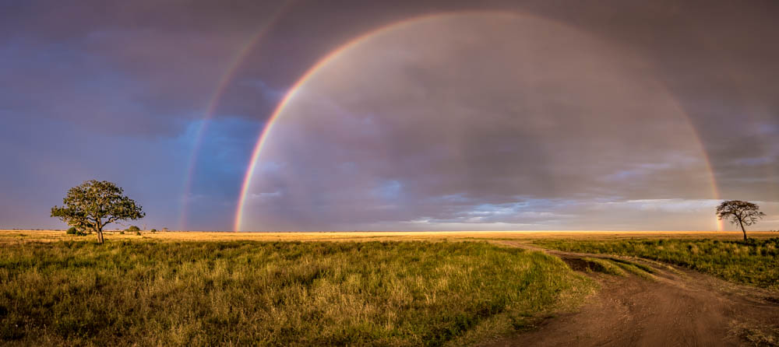
‘Shouldn’t we close our windows?!? ‘ … Silence…
This moment is what we came for. The two lions are standing so close to the jeep we could touch them, but we sense there’s no need to be scared. We aren’t. And neither are they. It’s magical.
Note: don’t be that stupid tourist who ACTUALLY tries to touch the animals, keep your arms and everything else inside the jeep!!
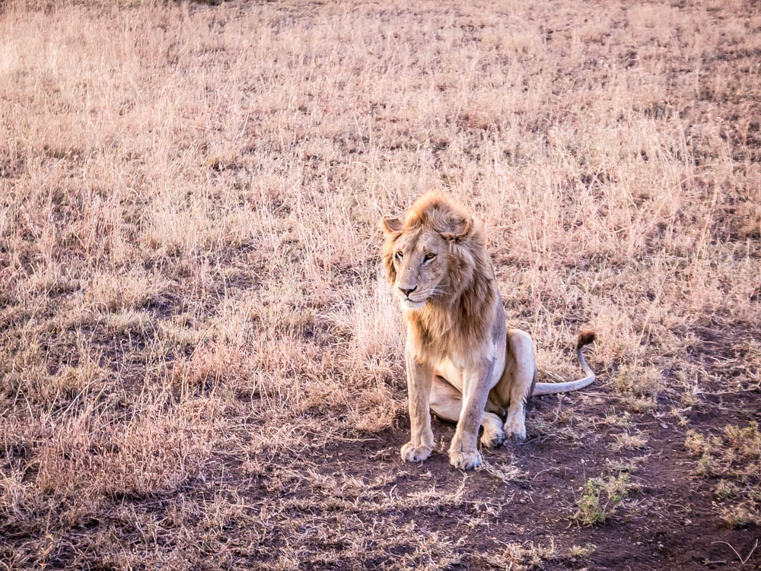

A safari in Serengeti national park
We’d left the camp site near Lake Manyara earlier that day and drove for a few hours before arriving at our camp for the night, inside the Serengeti. Dust had been the main theme of the ride, as dry season had arrived and there was not a drop of rain in sight. After dropping off our tents and luggage, it was time to get back out there, and take it a bit more pole pole – slowly.
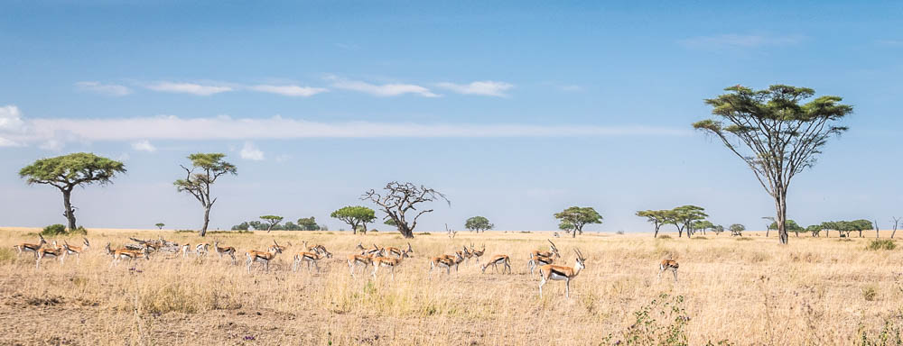
We head out into the ‘endless plains’ (*) of the majestic Serengeti singing ‘Can you feel the love tonight’. Little do we know exactly how much love we’re about to get… (**)
(*) Serengeti means ‘endless plains’ in Maasai language. / (**) Disney’s Lion King was inspired by the Serengeti.
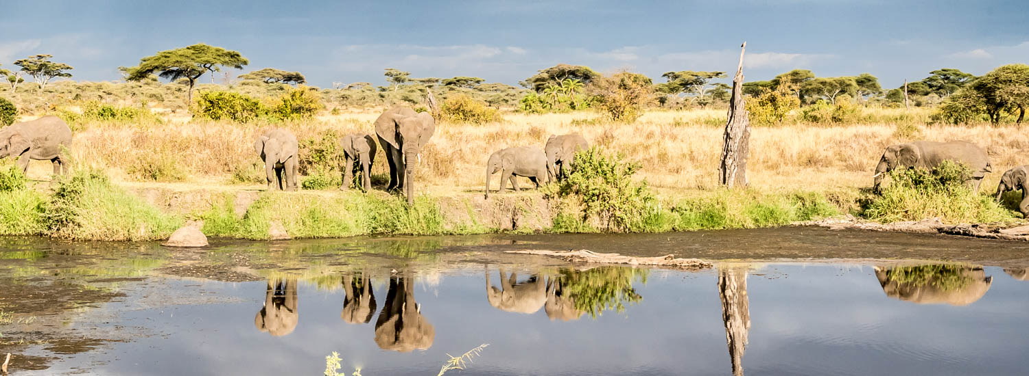
I get the best seat in the car, right next to the driver. It doesn’t take me long to open the roof, stand up on my seat and enjoy the show with the wind in my hair and the afternoon sun burning softly caressing my skin. #AllWorthItThough
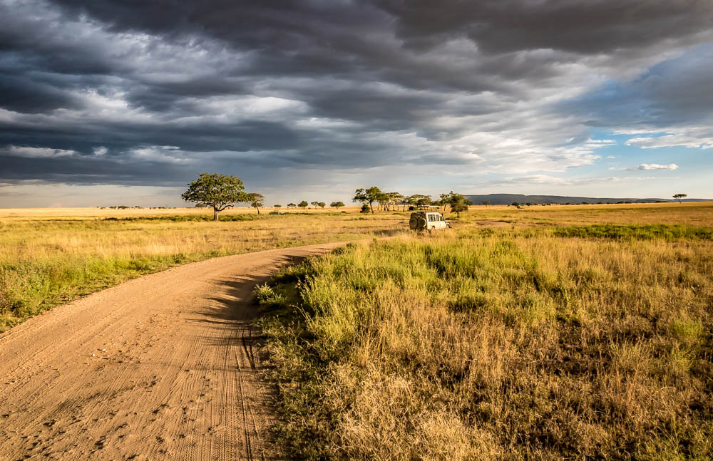
The afternoon views are close to perfect, but as sunset approaches, it becomes nature’s best all together in one place. The sky turns from an almost threatening dark blue to bright purple, and as if the full double rainbow wasn’t enough, we get a lion walking right into it, and another one sitting in a tree…
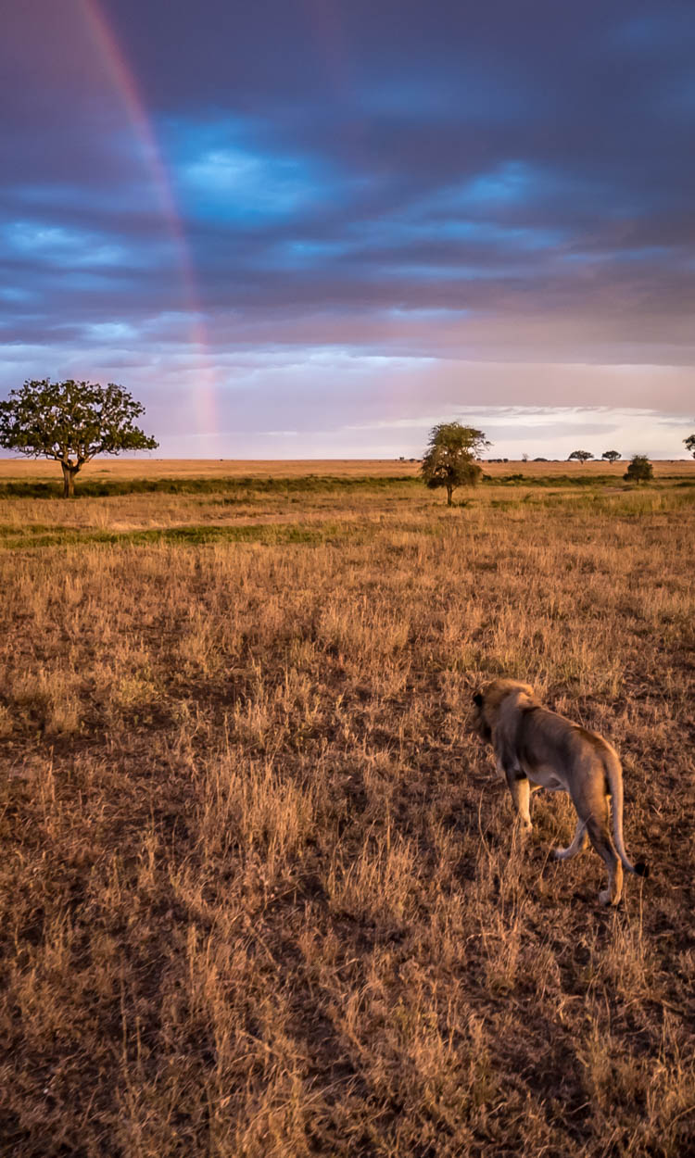
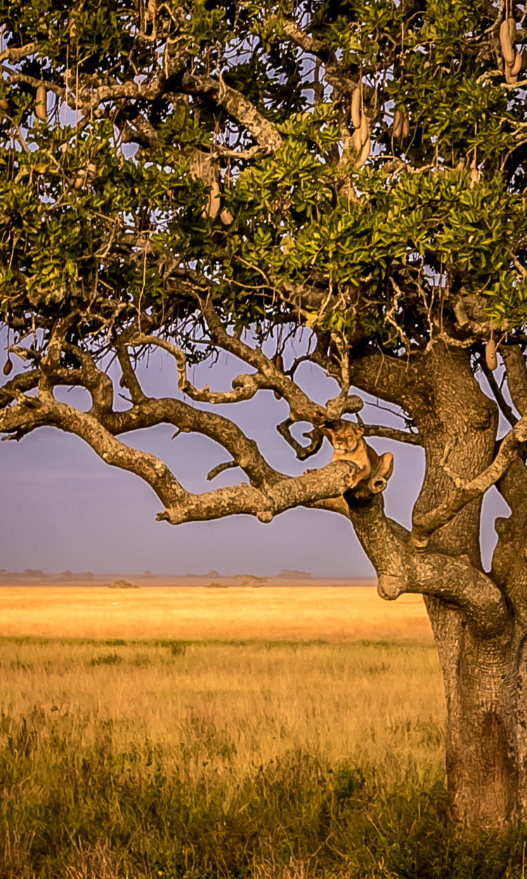
As the sun sets, the sky’s on fire, and two more lions willingly pose right in front of it (look closely, there’s another one a bit further back). It’s past 6 pm and park rules don’t even allow us to be driving around anymore, but we’ve completely lost track of time.
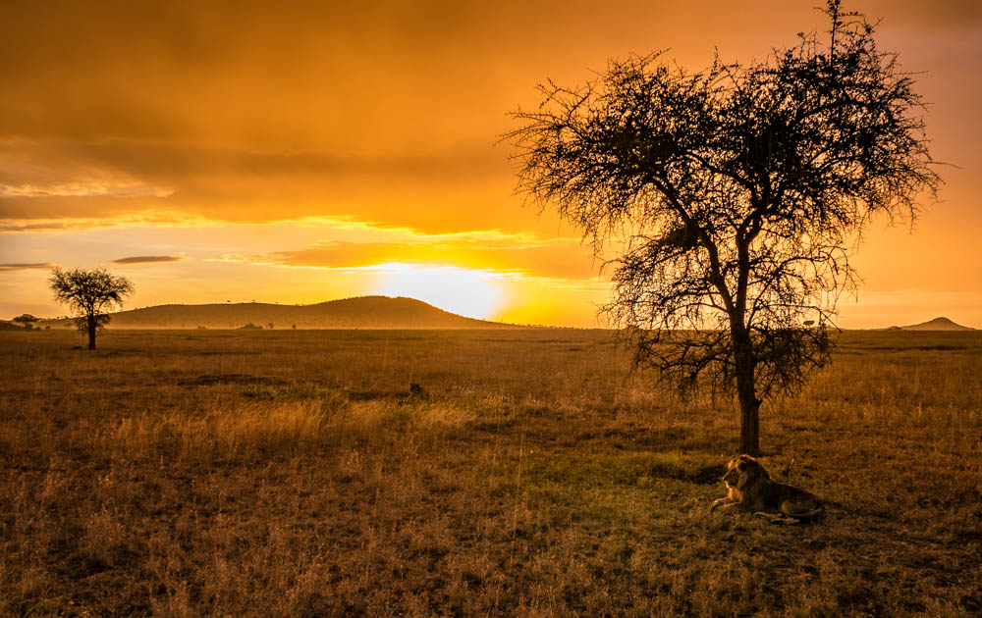
‘Prepare your cameras, keep your eyes open and shout if you see someone coming! ‘
‘What are you gonna…’ My heart stops for a few seconds while he drives the jeep off road and straight into the endless savannah. The lions get so close to the jeep we could touch them. It’s the perfect end of an already unbelievable day.
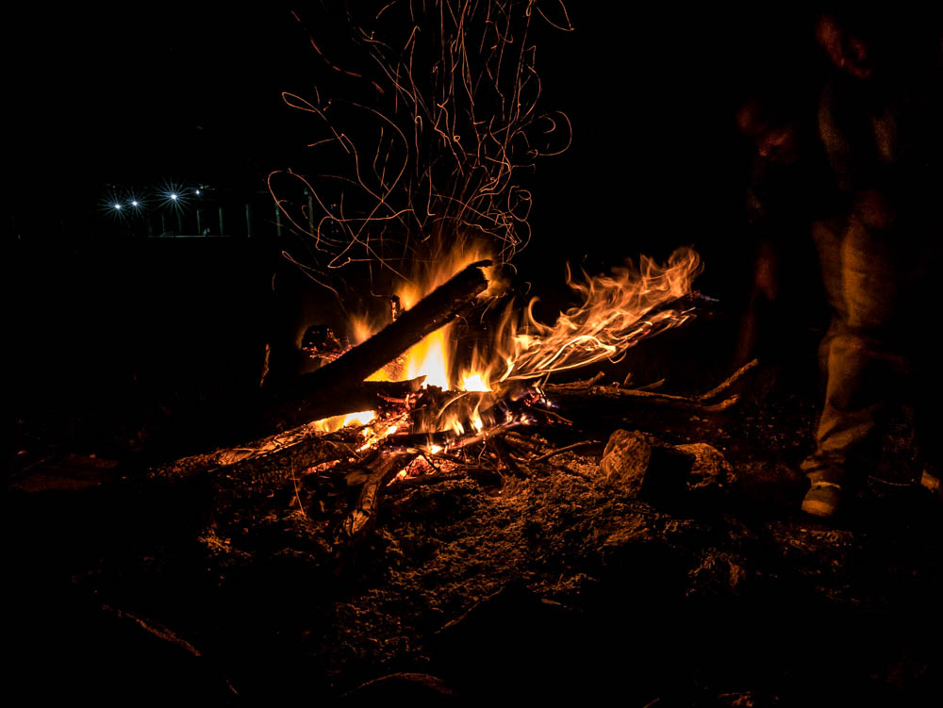
The next morning we wake up early for a sunrise drive, before leaving the park and heading to Ngorongoro crater for our last day. It’s cold but we don’t care. If day two’s half as perfect as day one, we’ll consider ourselves the luckiest girls in the world. We open the roof, start driving and quickly discover that yes, you CAN get THIS lucky 2 days in a row…
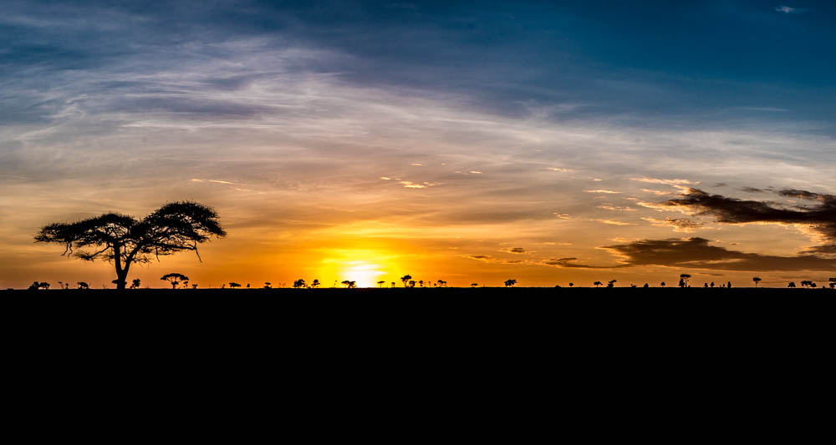
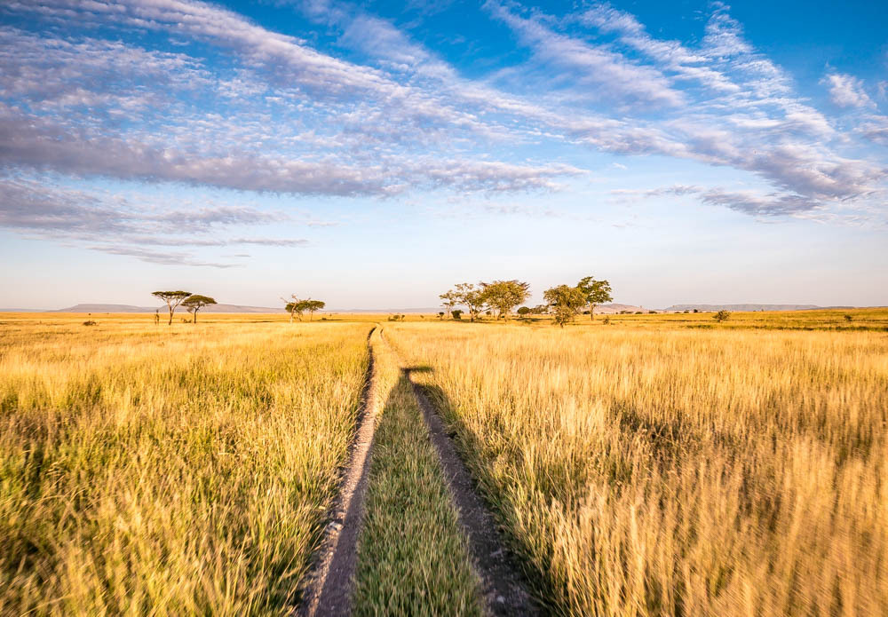
The first rays of sun turn the dry grass into gold and warm us up slowly. We spot them shortly after. The male carelessly showing off his manliness, the female tirelessly trying to impress him. It’s a game of seduction, of push and pull, of not giving up, and while reality is probably less romantic than the image in our imagination, we can’t help but just stand there and dream of everlasting love.
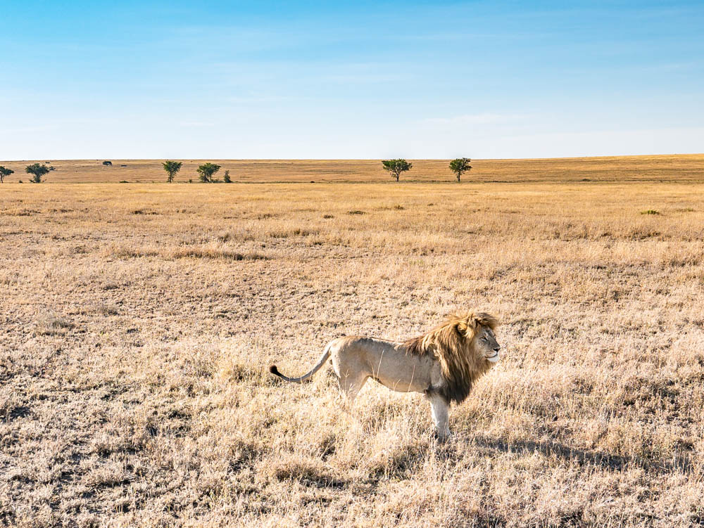
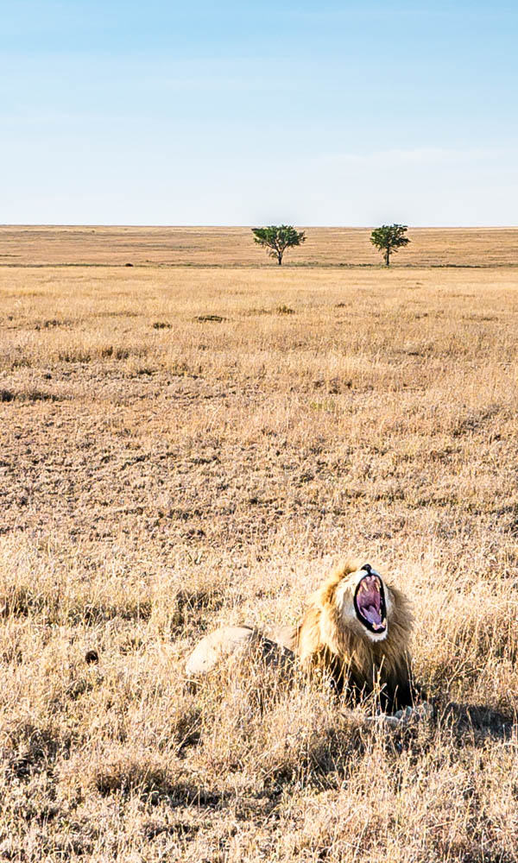
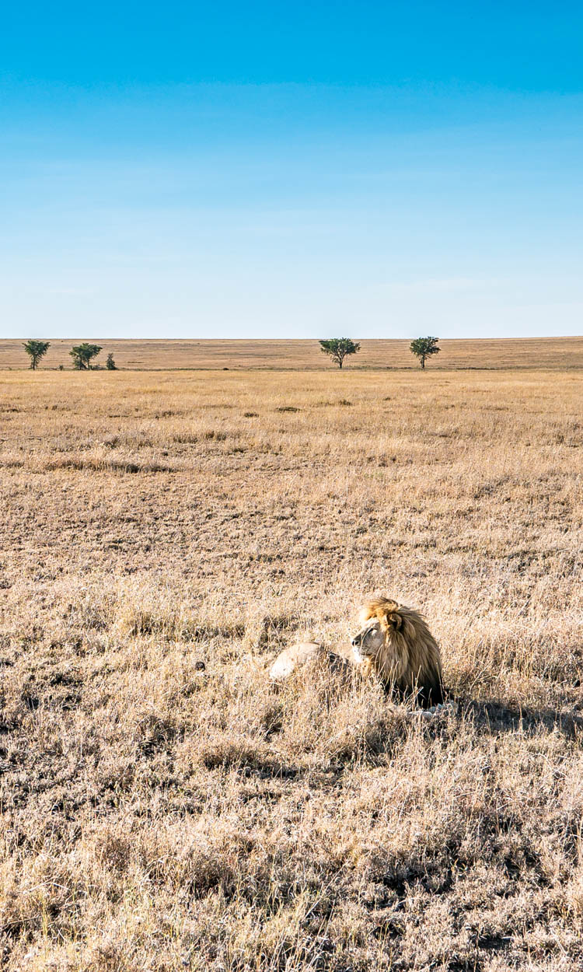
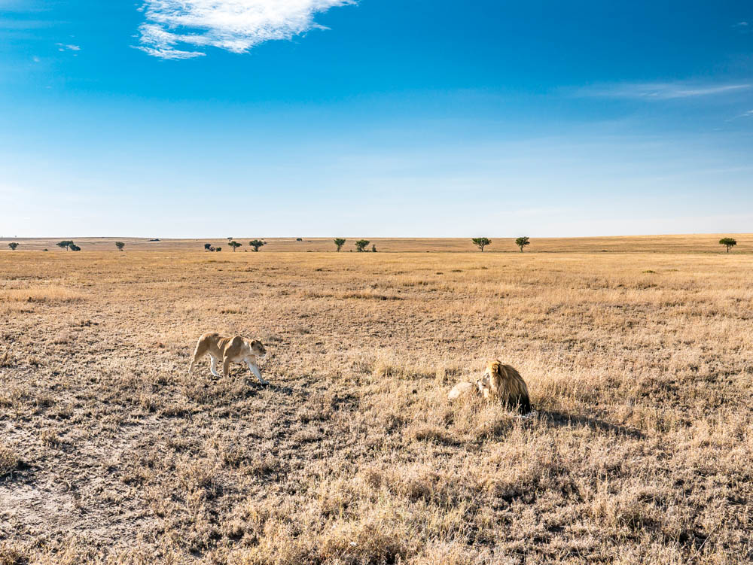
It goes on for more than 30 minutes before they decide to leave. Another male lion is approaching from far and the nearby rocks offer better shelter. The male takes the lead, and it’s almost as if he’s inviting us to follow them. Another 30 minutes pass by as we advance slowly, but we don’t get bored for even a second. ‘Can you feel the love today?‘ How could we not??
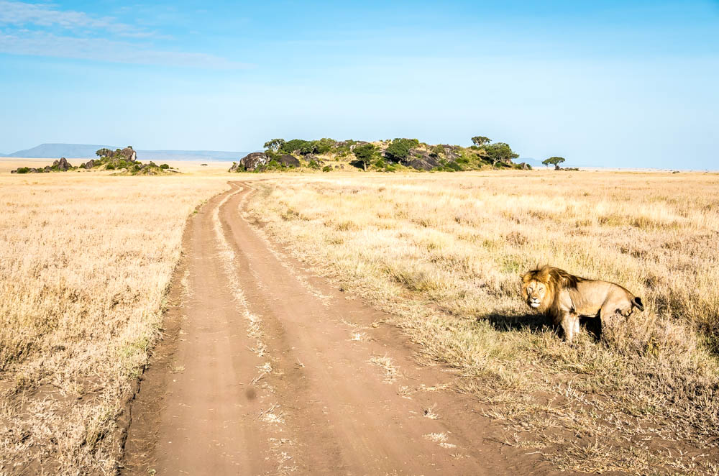
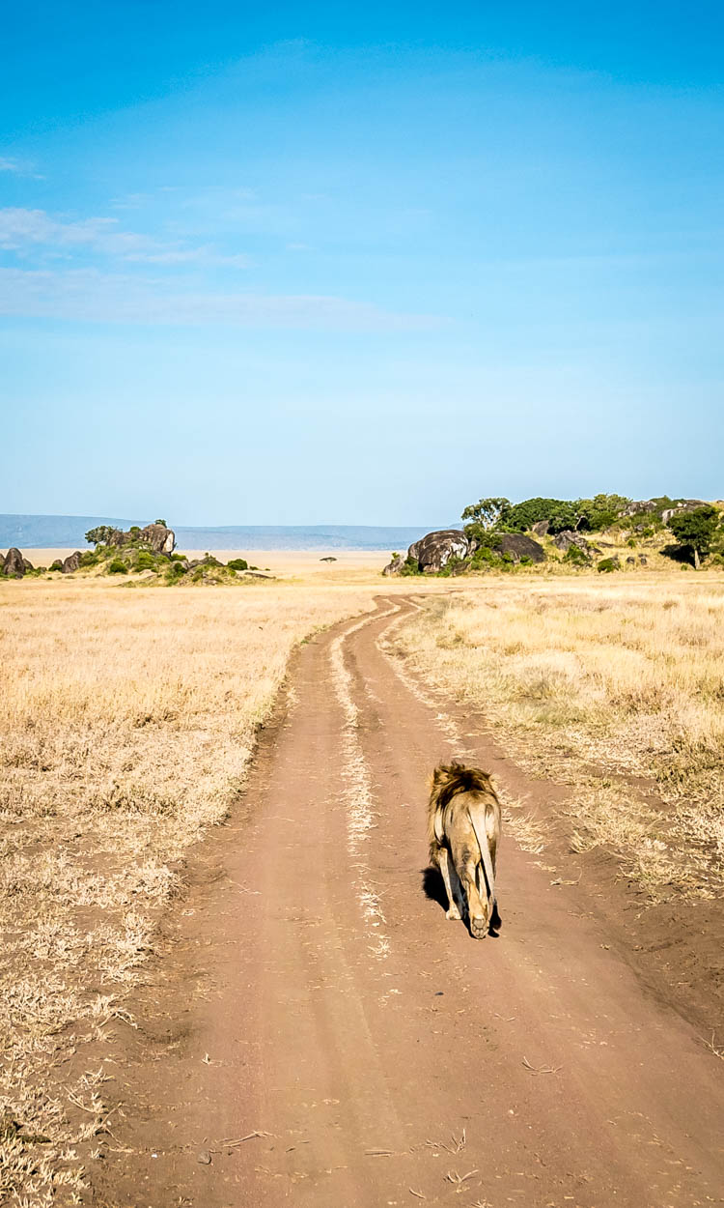
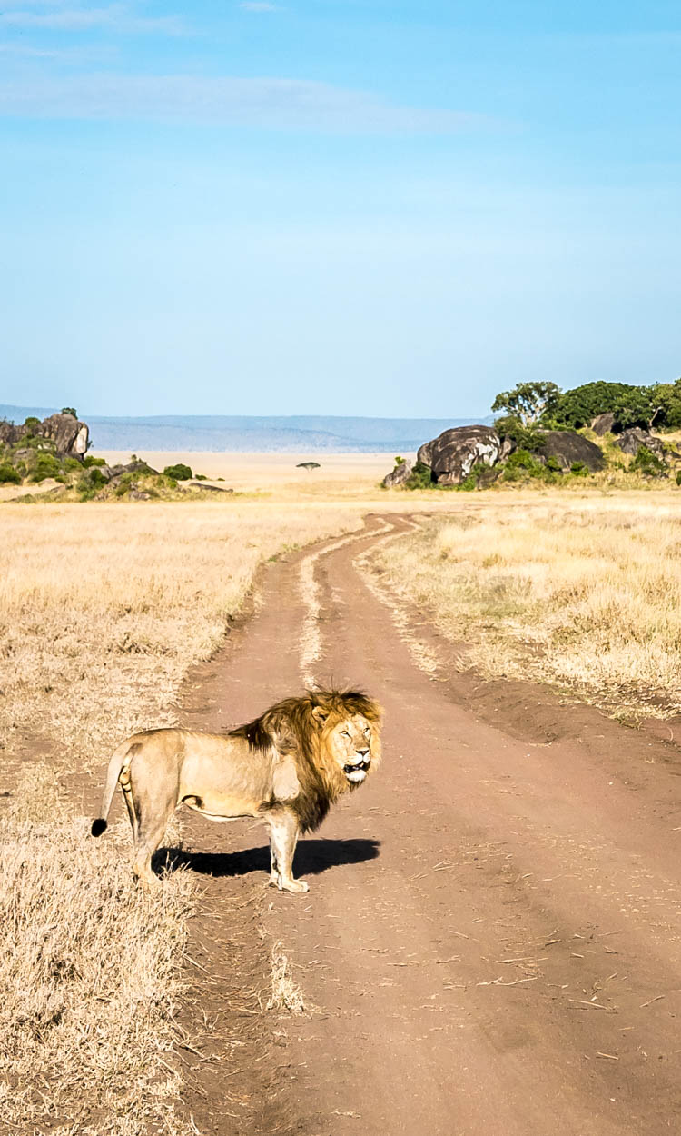
But our luck’s not over yet. A bit later we run into a whole group of lion cubs and their mothers, and right before we leave the park we spot a leopard jumping out of a tree. Big 5, 4 down, 1 left, with 1 day to go! With our fingers crossed for rhinos tomorrow (there are no rhinos in Lake Manyara or the Serengeti so our only chance to spot them will be Ngorongoro crater), we leave the Serengeti.
WHAT HAPPENED IN THE PAST TWO DAYS IS TOO GOOD TO BE TRUE.
The scenery of the Serengeti is stunning, but mother nature’s show of rainbows, picture-perfect skies, animals showing up at exactly the right time and jaw-dropping sunrises and sunsets made it indescribable. It feels like there’s even more dust than when we arrived, but the only theme of this ride is gratitude.
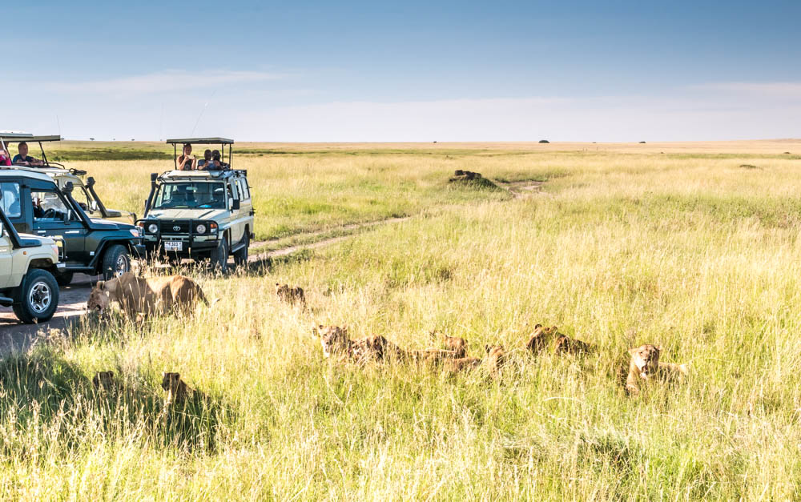

A Serengeti safari - practical
Famous for its migration of wildebeest and zebras, the Serengeti covers and area of about 30.000 km² in the north of Tanzania. It is without doubt my favorite park of the ones I visited in Tanzania (Lake Manyara, Serengeti and Ngorongoro), and one of the most magical places I’ve ever seen.
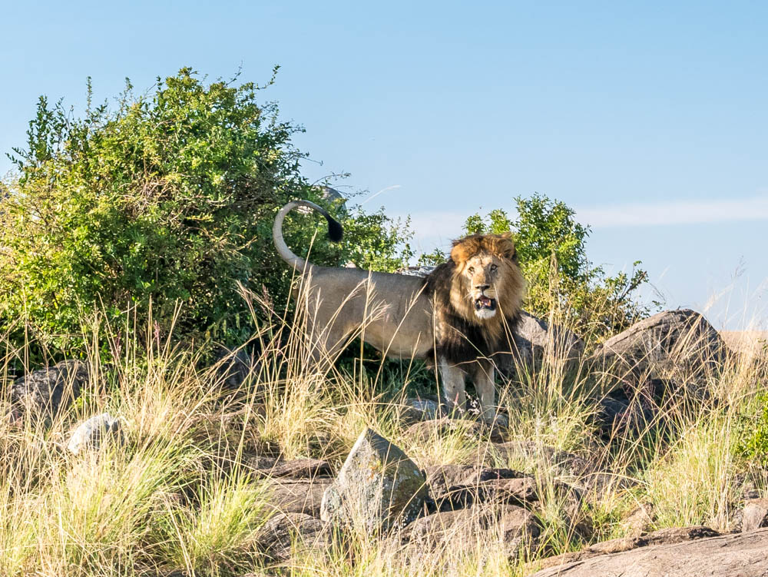
Budget travelers often choose to skip it because entrance fees are higher than those of other parks and getting there is quite costly too as it’s far from any city and you have to drive through Ngorongoro. This means you have to pay the entrance fee for Ngorongoro, and you have to pay it again when you actually visit this park, or when you drive back in case you choose not to visit it.
My idea about this? Whatever you do, don’t skip the Serengeti! Skip ANY other park if you’re on a tight budget, but go to the Serengeti! #EnoughSaid
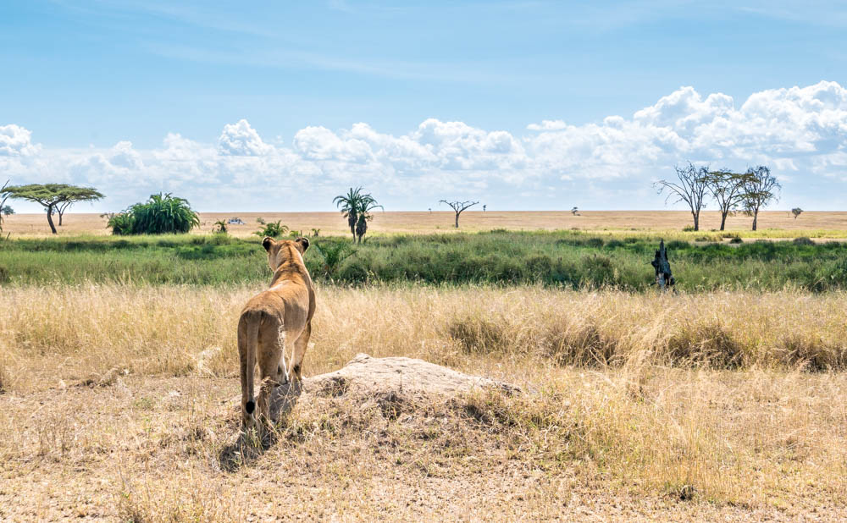
There’s several options to visit, according to your budget and time, but a combination of a sunset visit on day 1 with a sunrise drive the day after is just perfect! Depending on the time of the year you can witness the migration of the wildebeest, but you might need to go much further into the park, in which case you’ll need several days in total.
For more general safari information, head to my post about Lake Manyara, and stay tuned for more safari fun from Ngorongoro crater.
WANT TO VISIT THE SERENGETI AS WELL? ABOUT 2 YEARS AFTER MY FIRST VISIT I OPENED A TOUR BUSINESS IN TANZANIA AND WE CAN ORGANIZE THIS TRIP FOR YOU. HAVE A LOOK AT OUR WEBSITE AND GET IN TOUCH WITH ALL YOUR QUESTIONS!

THOUGHTS? QUESTIONS? SEE YOU IN THE COMMENT SECTION!!
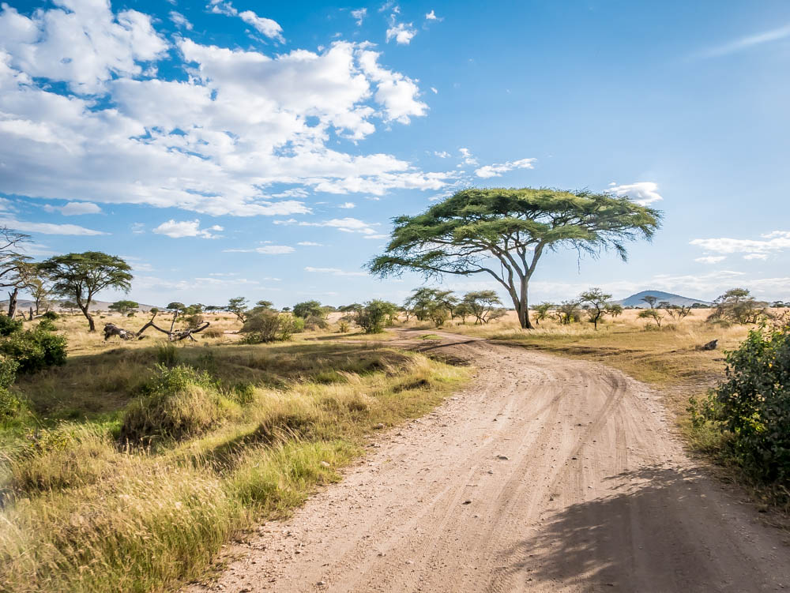
Disclaimer: this safari was fully paid for by yours truly and opinions are my own and straight from the heart, as always.

By Lili’s travel plan

Footer: © 2020 The Blog Abroad
Exclusive Member of Mediavine Travel
HomeFacebookTwitterLinkedinYouTubeInstagramPinterestEmail
Copyright © 2020 The Blog Abroad All Rights Reserved.
Everyone dreams of traveling to Europe, and there’s a reason why. Whether you’re taking your first solo trip, backpacking on a budget, looking for a ritzy getaway, or wanting to explore new cities and cultures (don’t forget about the food!), Europe has something for everyone.
In my opinion, Europe is one of the most diverse continents you can visit. It has a deep-rooted history and is a melting pot of cultures from all over the world – not to mention the unique architecture and cuisines that vary from country to country. Plus, it’s one of the easiest regions to travel with lots of transportation options and having countries so close together. So, what are you waiting for?
If you’re backpacking through Europe, the best time to travel to the region is during the offseason. From November to March, you’ll have better luck finding cheap flights and hotels slash their prices.
However, winter is also a busy time of year for people planning a ski vacation or wanting to experience the Christmas Markets. The busiest time of year is summer in Europe. From June to August, travelers from all over the world flock to the region to soak up the good weather.
If you’re planning a trip during these months, book as much of it as you can in advance. Flights, even with budget airlines, can triple in price!
Check out my Guide to Backpacking Europe to help you start planning your big adventure!

WHAT TO EXPECT
Eastern Europe: Eastern Europe generally refers to the countries that were behind the Iron Curtain. It’s made up of Belarus, Bulgaria, Czech Republic, Hungary, Poland, Moldova, Romania, Russia, Slovakia, and Ukraine. It’s a cheaper destination for budget travelers, and some of its top historical attractions include the Prague Castle, the State Hermitage Museum and Auschwitz.
Northern Europe: Northern Europe is known for its natural phenomena – the Northern Lights. If you want to see them, you’ll need to visit in the winter when conditions are at their best. Some of the countries that make up this region include Denmark, Estonia, Finland, Iceland, Norway, Sweden, and the United Kingdom.
Southern Europe: Southern Europe is made up of all the countries close to the Mediterranean. Spain, Italy, Malta, Greece, Croatia, Bosnia, and Herzegovina and Montenegro are some of the most visited destinations in the region. It’s known for its incredible sailing, natural wonders, and ancient history.
Western Europe: Western Europe is one of the most popular regions in Europe. It’s home to countries like Austria, France, Germany, Netherlands, and Switzerland that attract millions of visitors each year. Some of its top attractions are the Eiffel Tower, the Van Gogh Museum and the Alps

EY UPDATE: 15th September 2020
Key Update: since 15th September – and until the 30th September (for now), the whole of Portugal (not just Lisbon) has moved into a State of Contingency, which isn’t a State of Emergency, but has been put in place due to schools and work returning. From a tourist point of view this does not change much, except in relation to alcohol and evenings. Specifically, after 8pm alcohol can only be served in restaurants/places which serve food, and alcohol must be purchased with a meal. These establishments can remain accepting guests until mid-night, and must close by 01:00. The sale of alcohol is also restricted in supermarkets after 8pm.
BUT… Now, these laws can be adapted by municipality, depending on the local situation. So, local councils can allow establishments to remain open until 23:00 should they wish, for example, in the Faro District of the Algarve, this is their local rules, so drinking until 23:00 is allowed in bars without meals – so check local restrictions. In addition, the general, non-location specific law is a little confusing, as while it deems alcohol can only be consumed after 8pm in a restaurant, there is another clause that says it can’t be consumed on public roads after 8pm, so in my local area for example, the police are instead enforcing it as after 8pm you can still drink, but just inside, which I think is a misunderstanding but that shows how short-term many of these laws are, and how they aren’t always understood.
The cases are, sadly, rising quite significantly in Portugal (mainly Lisbon & The North) and while I think the country has done a really good job overall, it seems, like most of Europe we are heading towards a second wave. Importantly, while cases are rising, deaths remain relatively low, and it was very much expected that cases would rise with the return to schools, work, and normal life, hence this period of contingency during these two weeks. Our PM & President have been very vocal about no further nationwide lockdown, and protecting tourism in the Azores, Madeira and the Algarve in particular where cases have remained low – but, let’s see what the next few weeks bring. I still really suggest from a tourist point of view booking everything as last minute as you can, not just for Portugal, but any travels in 2020.
Main Article: Updated September 2020
Latest updates in article: UK Airbridges for Maderia & Azores, Trip Reports, New State of Contingency and rules from 15th September, Entrance Rules, COVID-19 Stats
Over the summer, in fact since May 18th, we’ve been able to get out and explore our beautiful country of Portugal. Personally, I’ve taken road trips in the Alentejo and Central Portugal regions, beach hopping at home in the Algarve, spent a month in Lisbon for a language course and two weeks in The Azores, so have a fairly good idea about how each part of the country feels like as a tourist. Throughout, I’ve felt safe, secure and that our nation has taken precautions and health and safety seriously. Now, most Portugal coronavirus restrictions have been lifted for some countries.
For sure, many of us in the world are in the same boat when it comes to lockdowns, to varying degrees and different stages, and have likely seen a lot of our plans for 2020 cancelled. If however, you are planning to travel to Portugal in 2020, I wanted to give some insight into life on the ground, the current rules, and what has been put in place to best control coronavirus in Portugal, particularly when travelling.
*Please note, this is a fast-moving situation and the information provided below is done so in good faith at the time of writing. There are various sources linked out to throughout the article, and particularly at the bottom, however, DanFlyingSolo takes no responsibility for the information provided here and urges you to check all official sources for updates.
For the most part, I have been impressed as a Portuguese resident at the coronavirus situation in Portugal, how it was managed initially, but also with the COVID-19 travel set up in Portugal. I’ve been on many trips in the last month, and (as far as I’m aware) have not had the virus, indeed both my tests have been negative, but I’m being wary and taking all the personal precautions I can, and will try to detail the real situation below.
Some of the most popular beaches, like Carvoeiro, were quieter than normal and have monitoring
While I was very supportive of the lockdown initially, I very much saw it as an opportunity to get the health system prepared, and Portugals coronavirus rules and precautions in place before reopening. I didn’t see it as a permanent solution, but preparation time. Tourism is a huge part of life here in Portugal, especially in some regional, seasonal destinations like the Algarve.
It’s easy to dismiss concerns of ‘the economy’ as huge businesses, stock-markets and corporate bailouts, but there are so many small, family-run businesses here reliant on tourism, and no income this summer, means no money to pay the bills in winter – this will of course lead to huge social issues and even in a relatively left-leaning, semi-socialist country, that will become a problem,
As such, I support travel reopening, with the right restrictions in place, and if you are comfortable travelling right now, and can be respectful and take those precautions great – I fully understand it isn’t for everyone just now, but I don’t think we should be shaming everyone who is deciding to travel in the most responsible way they can either.
Here is the current situation for Portugal travel restrictions, and how my recent trips in Portugal have gone down. You can also find a list of resources at the bottom of this page (in various languages) to keep updated, and I’ll aim to update this post weekly.

